14th ICCET 2026
MARCH 22nd-23rd, 2026

PRINCE SHRI VENKATESHWARA PADMAVATHY ENGINEERING COLLEGE & OSIET Chennai

In Collaborated with

SAMARKAND STATE UNIVERSITY, UZBEKISTAN

PAPER ID – ICCET268352
Instructions to complete the Registration:
Step 1- Complete the conference payment UPI ID – 8189118689@indianbk
(Note- conference payment only)

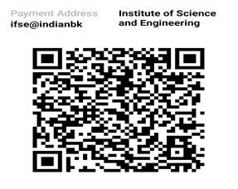

Category | National Participants (INR) | International Participants (USD)
Student/Faculty/Research Scholar/Industry Participant  (Single Author – 1 certificate) (Only for Online Presentation) | Rs. 1800 | USD 25
Students Faculties/Research Scholars/Industry Participants  (Group of 2 to 5 members – 2 to 5 certificates) (Combination of Student/Faculty/Research Scholar/Industry Participant) (Only for Online Presentation) | Rs. 2200 | USD 30
Students Faculties/Research Scholars /Industry Participants (Group of 6 to 7 members – 6 to 7 certificates) (Combination of Student/Faculty/Research Scholar/Industry Participant)(Only for Online Presentation) | Rs. 2550 | USD 35
Student/ Faculty/Research Scholar/Industry Participant  (Single Author– 1 certificate)(Only for those you attend physically in our campus) | Rs. 2200 | USD 30
Students Faculties/Research Scholars/Industry Participants  (Group of 2 to 5 members – 2 to 5 certificates) (Combination of Student/Faculty/Research Scholar/Industry Participant) (Only for those you attend physically in our campus) | Rs. 2950 | USD 50
Students Faculties/Research Scholars/Industry Participants  (Group of 6 to 7 members – 6 to 7 certificates) (Combination of Student/Faculty/Research Scholar/Industry Participant) (Only for those you attend physically in our campus) | Rs. 3550 | USD 60

Step 2- Kindly fill the declaration form (page 8 and 9), Select the journal (page 2), RESEARCH PAPER (final paper) in word format only.
Note - Kindly add the correct author Name, Designation, Department, College/University/Industry, and Email id of all the authors in full paper

Step 3- All the below details (In a single email with paper id in subject of the email ) should be mailed to iccet2026@gmail.com

- Declaration form and Journal
- RESEARCH PAPER (final paper in word format)
- Screenshot of final payment (Conference payment)
- Certificate form excel (note - type and save the file)

Note: Please always user the paper ID in the subject for any communication.
2. JOURNAL CATEGORY (Please tick one Option): -
- Please tick one Option.
- Note – Journal fee should be paid on or before 31st March 2026 and share the screen shot of journal payment to iccet2026@gmail.com (mention the paper id and journal name in subject)
- Account details for Journal Payment available in page 9

Journal code | Journal Name | ISSN | Indexing | Price | Please tick anyone
1 | Not interested in Journal Publication. |  |  | N/A
2 | International Journal of Science and Innovative Engineering & Technology(IJSIET) |  | GOOGLE SCHOLAR | Free
3 | JOURNAL OF CURRENT RESEARCH IN ENGINEERING AND SCIENCE  http://www.psvpec.in/jcres/jcres.html | ISSN:2581-611X | GOOGLE SCHOLAR | Free
3a | Engineering and Applied Science Research | ISSN:2539-6161  E-ISSN:2539-6218 | SCOPUS | Free
3b | Operational Research in Engineering Sciences: Theory and Applications | ISSN:2620-1607E-ISSN:2620-1747 | SCOPUS | Free
3c | Indonesian Journal of Science and Technology | ISSN:2528-1410 | SCOPUS | Free
4 | CRC PRESS (Taylor and Francis)- ENGG & TECH |  | SCOPUS | 15000
5 | IEEE Explorer  Note - First source index less than 2%  NO OF PAGES LESS THAN 10 (IEEE format)  PLAG BELOW 10% |  | SCOPUS | 14900 | 
6 | AIP  Note - First source index less than 2%  NO OF PAGES LESS THAN 10 (IEEE format)  PLAG BELOW 10% |  | SCOPUS | 14950
7 | Lecture Notes in Networks and Systems  Note - First source index less than 2%  NO OF PAGES LESS THAN 10 (Springer format)  PLAG BELOW 10% |  | SCOPUS | 14900
8 | SMSAMS PUBLICATIONS  https://sites.google.com/view/smsams/home/ |  | GOOGLE SCHOLAR | 1500
9 | International Journal of Computer Science and Mechatronics(IJCSM)  https://www.ijcsm.in/ | ISSN: 2455-1910 | ICI/GOOGLE SCHOLAR | 2000
10 | International Journal of Advanced Research in Basic Engineering Sciences and Technology(IJARBEST) | E-ISSN:2456-5717 | GOOGLE SCHOLAR, THOMSON REUTER | 1200
11 | International Journal of Advanced Research in Management, Architecture, Technology & Engineering(IJARMATE) | E-ISSN: 2454-9762 | GOOGLE SCHOLAR, THOMSON REUTER | 1200
12 | Communications on Applied Nonlinear Analysis | ISSN 1074-133X | Q3 (ENGINEERING Papers accepted – multidisplinary ) | 14500
13 | Panamerican Mathematical Journal | ISSN 1064-9735 | Q3 ,UGC  (ENGINEERING Papers accepted – multidisplinary ) | 14500
14 | Bio Web of conference |  | SCOPUS | 14950
15 | Journal of technical science |  | Scopus /wos | 60500
16 | Journal of Wireless Mobile Networks, Ubiquitous |  | Q3 SCOPUS ,UGC | 79000
17 | JOURNAL OF INTERNET SERVICES |  | Q2 SCOPUS,UGC | 95000
18 | Journal of Information Sources |  | Q1 - SCOPUS , UGC | 95000
19 | REVISTA ARGENTINA DE CLINICA |  | ANNA UNIVERSITY ANNEXURE - 1 | 60000
20 | Emerging Technologies for Disaster Response and Resilience in Smart Cities  Note - Citations: Intext citation within chapter as per APA 7th edition for e.g., for single author then the last name and year before full stop- (Kumar, 2024), for two authors- (Kumar & Kumar, 2024) and for multiple author- (Kumar et al., 2024)  Note-  - Normal plagiarism should be below 12%  - AI plagiarism should be below 12%  - No of Pages should be minimum 18  - 8000 words |  | SCOPUS  (book chapter) | 9000
21 | AI and Innovation in HRM: The Future of Strategic HR in the Service Economy  Note - Citations: Intext citation within chapter as per APA 7th edition for e.g., for single author then the last name and year before full stop- (Kumar, 2024), for two authors- (Kumar & Kumar, 2024) and for multiple author- (Kumar et al., 2024)  Note-  - Normal plagiarism should be below 12%  - AI plagiarism should be below 12%  - No of Pages should be minimum 18  - 8000 words |  | SCOPUS  (book chapter) | 9000
22 | Sustainable Healthcare Systems: Technologies, Practices and Management  Note - Citations: Intext citation within chapter as per APA 7th edition for e.g., for single author then the last name and year before full stop- (Kumar, 2024), for two authors- (Kumar & Kumar, 2024) and for multiple author- (Kumar et al., 2024)  Note-  - Normal plagiarism should be below 12%  - AI plagiarism should be below 12%  - No of Pages should be minimum 18  - 8000 words |  | SCOPUS  (book chapter) | 9000
23 | Cloud-Based Remote Monitoring and Management  Note - Citations: Intext citation within chapter as per APA 7th edition for e.g., for single author then the last name and year before full stop- (Kumar, 2024), for two authors- (Kumar & Kumar, 2024) and for multiple author- (Kumar et al., 2024)  Note-  - Normal plagiarism should be below 12%  - AI plagiarism should be below 12%  - No of Pages should be minimum 18  - 8000 words |  | SCOPUS  (book chapter) | 9000
24 | Security Paradigms in 6G Smart Cities and IoT Ecosystems Navigating Future  Note - Citations: Intext citation within chapter as per APA 7th edition for e.g., for single author then the last name and year before full stop- (Kumar, 2024), for two authors- (Kumar & Kumar, 2024) and for multiple author- (Kumar et al., 2024)  Note-  - Normal plagiarism should be below 12%  - AI plagiarism should be below 12%  - No of Pages should be minimum 18  - 8000 words |  | SCOPUS  (book chapter) | 9000
25 | Publication Book Title: Artificial Intelligence for Climate Change Mitigation: The Key Motivations and Combating Methods  Note - Citations: Intext citation within chapter as per APA 7th edition for e.g., for single author then the last name and year before full stop- (Kumar, 2024), for two authors- (Kumar & Kumar, 2024) and for multiple author- (Kumar et al., 2024)  Note-  - Normal plagiarism should be below 12%  - AI plagiarism should be below 12%  - No of Pages should be minimum 18  - 8000 words |  | SCOPUS  (book chapter) | 9000
26 | Quantum AI and its Applications in Blockchain Technology  Note - Citations: Intext citation within chapter as per APA 7th edition for e.g., for single author then the last name and year before full stop- (Kumar, 2024), for two authors- (Kumar & Kumar, 2024) and for multiple author- (Kumar et al., 2024)  Note-  - Normal plagiarism should be below 12%  - AI plagiarism should be below 12%  - No of Pages should be minimum 18  - 8000 words |  | SCOPUS  (book chapter) | 9000
27 | Green Policies and AR in InsurTech  Keywords in paper: 3D CAD Models,AR,Digital Twin in Insurance Industry  Note - Citations: Intext citation within chapter as per APA 7th edition for e.g., for single author then the last name and year before full stop- (Kumar, 2024), for two authors- (Kumar & Kumar, 2024) and for multiple author- (Kumar et al., 2024)  Note-  - Normal plagiarism should be below 12%  - AI plagiarism should be below 12%  - No of Pages should be minimum 18  - 8000 words |  | SCOPUS  (book chapter) | 8950
28 | Metaheuristic Algorithms, Sustainable Computing, and Intelligent Systems Applications  Publisher: Wiley  Keywords in paper: Metaheuristic algorithms for neural network optimization, Sustainable computing approaches in neural networks  Note - Citations: Intext citation within chapter as per APA 7th edition for e.g., for single author then the last name and year before full stop- (Kumar, 2024), for two authors- (Kumar & Kumar, 2024) and for multiple author- (Kumar et al., 2024)  Note-  - Normal plagiarism should be below 12%  - AI plagiarism should be below 12%  - No of Pages should be minimum 18  - Minimum 8000 words |  | SCOPUS  (book chapter) | 8950
29 | Actionable Intelligence for Engineering and Technological Transformation  Publisher: CRC Press  Keywords in paper: Predictive Maintenance and Diagnostics, Process Optimization and Automation,Smart Energy Management,Intelligent Building Systems  Note-  - Normal plagiarism should be below 12%  - AI plagiarism should be below 12%  - No of Pages should be minimum 18  - Minimum 8000 words |  | SCOPUS  (book chapter) | 8950
30 | Harnessing AI to reshape Future of Agriculture  Publisher: IGI  Keywords in paper: AI and Sustainable Farming, Smart Farming, AI & Agriculture  Note - Citations: Intext citation within chapter as per APA 7th edition for e.g., for single author then the last name and year before full stop- (Kumar, 2024), for two authors- (Kumar & Kumar, 2024) and for multiple author- (Kumar et al., 2024)  Note-  - Normal plagiarism should be below 12%  - AI plagiarism should be below 12%  - No of Pages should be minimum 18  - Minimum 8000 words |  | SCOPUS  (book chapter) | 8950
31 | Metaheuristic Algorithms, Sustainable Computing, and Intelligent Systems Applications  Keywords in paper: Metaheuristic algorithms for neural network optimization, Sustainable computing approaches in neural networks  Note-  - Normal plagiarism should be below 12%  - AI plagiarism should be below 12%  - No. of Pages should be minimum 18  - Minimum 8000 words |  | SCOPUS  (book chapter) | 9000
32 | Green Policies and AR in InsurTech  Publisher: Emerald Publishing  Keywords in paper: 3D CAD Models,AR,Digital Twin in Insurance Industry  Note-  - Normal plagiarism should be below 12%  - AI plagiarism should be below 12%  - No of Pages should be minimum 18  - Minimum 8000 words |  | SCOPUS  (book chapter) | 9000
33 | Innovating Businesses with Artificial Intelligence  Publisher: Peter Lang, Switzerland  Keywords in paper: Impact of AI on Business Transformation, AI in smart grids and automation, AI in Precision farming and crop monitoring, AI in Contract analysis  Note-  - Normal plagiarism should be below 12%  - AI plagiarism should be below 12%  - No of Pages should be minimum 18  - Minimum 8000 words |  | SCOPUS  (book chapter) | 9000
34 | Haptic Feedback Control in Medical Robotics  Keywords in paper: Human Touch Perception, Haptic Sensing Technologies, Haptic Interfaces in Rehabilitation Robotics, Energy Efficiency in Haptic Medical Devices  Note-  - Normal plagiarism should be below 12%  - AI plagiarism should be below 12%  - No of Pages should be minimum 18  - Minimum 8000 words |  | SCOPUS  (book chapter) | 9000

Journal payment details -
(Note - Author can pay the journal fee on or before 31st March 2026)
After paying the journal fee, kindly share the payment screen shot to iccet2026@gmail.com. Mention the paper id in the subject of the email.
Payment method – INTERNET BANKING (RTGS, NEFT, GPAY) AND CASH DEPOSIT IN BANK OR ATM
Account Name – VENKATESH
Account number – 20420110051290
Name of the Bank – UCO BANK, KOYAMBEDU BRANCH (2042)
IFSC Code – UCBA0002042
Please pay the amount and send us the screen shot of the Statement/Payment copy.

CONFERENCE ATTENDANCE:

Choose one option from the below-
Option 1: ONLINE
How many will attend: 2
NOTE - Registration done after 21st March 2026 (11.59 AM) will be considered as Option 3

Option 2: ATTENDING CONFERENCE AT COLLEGE
How many will attend ________

NOTE - Registration done after 19th March 2026 will be considered as Option 1

Option 3: (Inabsentia) –
Please share your presentation PPT to iccet2026@gmail.com

NOTE - Registration open till 23rd March 2026

Note – Conference Certificates will be provided for Online, Offline and Inabsentia category

DECLARATION & Copyright transfer form
for ICCET 2026 TO BE SIGNED BY AUTHORS I/We, the undersigned author(s) of the manuscript entitled,
Title: Application-Integrated Multi-Agent AI Governance Framework for Automated Compliance Auditing
Paper id: ICCET268352
Authors: Pooja Ellanti, Adhira Srikanth, Dr. S. Ashwini
Hereby declare that (a) the above manuscript which is submitted for publication in the ICCET 2026 is not under consideration elsewhere. (b) The manuscript is not published already in part or whole (except in the form of abstract) in any journal or magazine for private or public circulation. The work described in the manuscript is my/our own and my/our
Individual contribution to this work is significant enough to qualify authorship. (c) No one who has contributed significantly to the work has been denied authorship and those who helped have been duly acknowledged. (d) Free journal category for publication will be considered only if the article meets the journal requirement and with good quality. There is no assurance for publication in any journal unless the quality of the article meets requirement of the journal and editors has all right to reject the paper (e) Indexing of articles and Digital Object Identifier activation will be sole responsible of respective author/s once published. (f) Journal payment received are inclusive of service charge, tax, any refund once paid will be refunded with service charges and tax deduction. (g) Paper can be rejected if it doesn’t meet the journal standard or not in scope. Article should be grammar error free and plagiarism should be less, do not use any AI generated content like chatgpt or quilibot. (h) Paper publication once processed in journal cannot be withdrawn, any withdrawn with the processed paper will attract 80%-100% of the journal fee based on the journal/s. (i) all journal/reviewer corrections are expected to be received within the timeline mentioned. Failure to follow will lead to paper rejection. (j) I/we also agree to the authorship of the article in the following sequence:

Authors Name 1. Pooja Ellanti
Mail id and mobile number pe4111@srmist.edu.in 9154315236

Authors Name 2. Adhira Srikanth
Mail id and mobile number as2611@srmist.edu.in 8939640520

Authors Name 3. Dr. S. Ashwini
Mail id and mobile number ashwinis1@srmist.ed.in 9952993184

NOTE: 1. Authors is required to sign this form. Signature (s) 1. 
2. 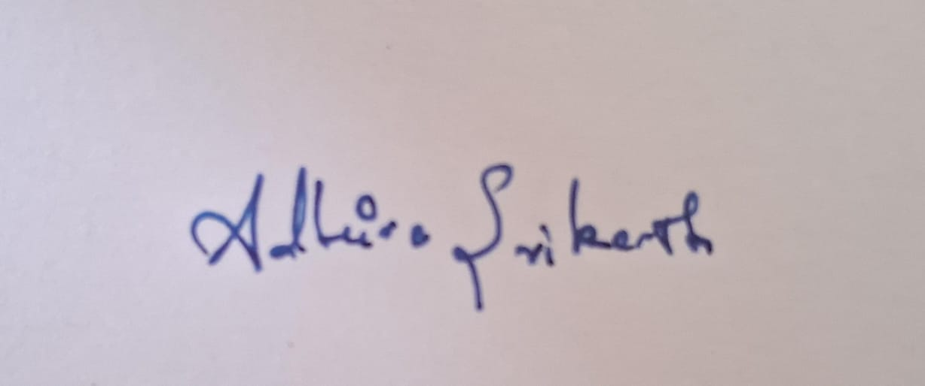
3. 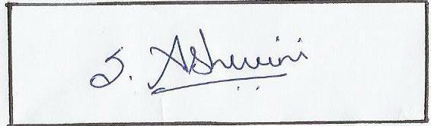

2. No addition, deletion or change in the sequence of authors is allowed at the later stage without valid reasons.

